Opponents:
bd. no. | dealer | vul. | contract | decl. | lead | tricks | result |  | IMPs
 |  |  |  |  |  |  | NS | EW | IMPs
1 | N | ---
2 | E | NS
3 | S | WE
4 | W | All
5 | N | NS
6 | E | WE
7 | S | All
8 | W | ---
9 | N | WE
10 | E | All
Opponents:
bd. no. | dealer | vul. | contract | decl. | lead | tricks | result |  | IMPs
 |  |  |  |  |  |  | NS | EW | IMPs
11 | S | ---
12 | W | NS
13 | N | All
14 | E | ---
15 | S | NS
16 | W | WE
17 | N | ---
18 | E | NS
19 | S | WE
20 | W | All
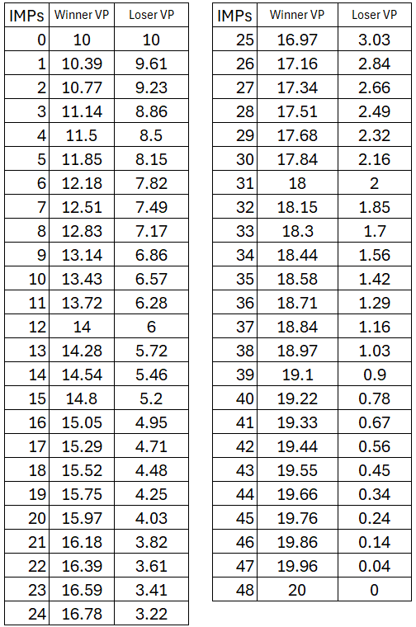
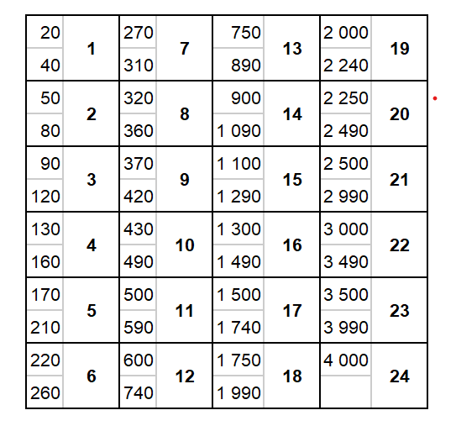
VP Conversion Table
IMP Conversion Table
Total:

Opponents:
bd. no. | dealer | vul. | contract | decl. | lead | tricks | result |  | IMPs
 |  |  |  |  |  |  | NS | EW | IMPs
21 | N | NS
22 | E | WE
23 | S | All
24 | W | ---
25 | N | WE
26 | E | All
27 | S | ---
28 | W | NS
29 | N | All
30 | E | ---
Total:

Notes

Total:

