Opponents:
bd. no. | dealer | vul. | contract | decl. | lead | tricks | result |  | IMPs
 |  |  |  |  |  |  | NS | EW | IMPs
1 | N | ---
2 | E | NS
3 | S | WE
4 | W | All
5 | N | NS
6 | E | WE
7 | S | All
8 | W | ---
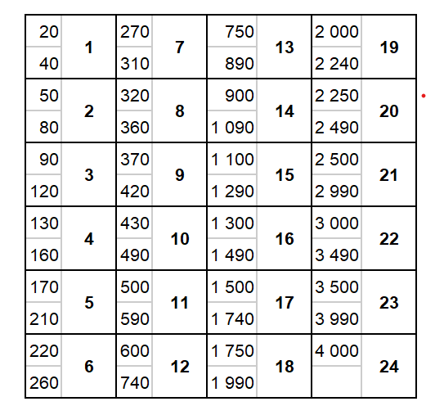
Total:
VP Conversion Table
IMP Conversion Table
Opponents:
bd. no. | dealer | vul. | contract | decl. | lead | tricks | result |  | IMPs
 |  |  |  |  |  |  | NS | EW | IMPs
9 | N | WE
10 | E | All
11 | S | ---
12 | W | NS
13 | N | All
14 | E | ---
15 | S | NS
16 | W | WE
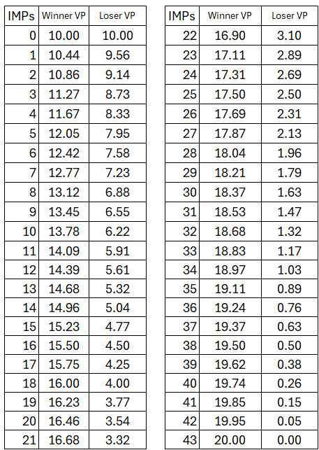
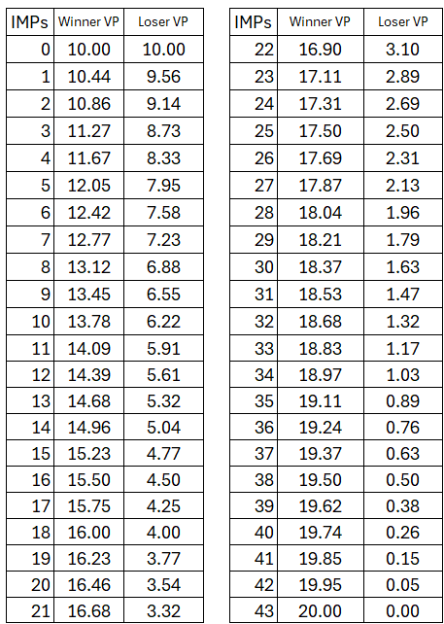
VP Conversion Table

\
Total:
Opponents:
bd. no. | dealer | vul. | contract | decl. | lead | tricks | result |  | IMPs
 |  |  |  |  |  |  | NS | EW | IMPs
17 | N | ---
18 | E | NS
19 | S | WE
20 | W | All
21 | N | NS
22 | E | WE
23 | S | All
24 | W | ---

Notes

Total:

